Checklist for DNA & CELL DIVISION TEST

Year 11 Human Biology

Know what molecules make up DNA and how they bond with each-other.

What is the shape of the DNA in the nucleus and the mitochondria

What shapes are used to represent each type of nucleotide

Be able to describe each stage of Mitosis and know the products of cell division

Know and be able to describe the parts of the sexual reproduction system in males and females

How is DNA stored in the nucleus and what is it called?

Know the steps of how RNA is formed from DNA and its path from the nucleus

What are proteins made of?

Describe the steps of fertilisation and where in the body it occurs

Be able to describe each stage of Meiosis and know the products of this type of cell division

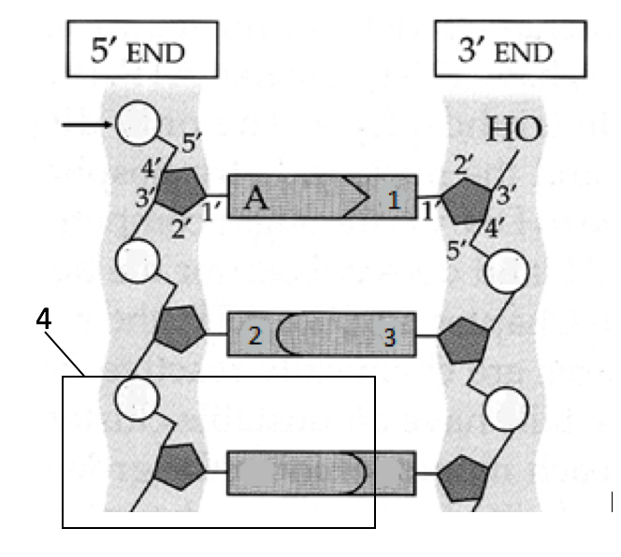

Be able to name the structures at

A, B, C, 1, 2, 3 and 4

What is meant by the 5’ end and 3’ end?

B



C→→→

Describe the process of DNA replication

Know the similarities and differences between RNA and DNA

Why is mitosis essential for multicellular organisms?

Know several causes of different types of cancer and their treatments

Male reproductive system – Know the organs. Which structure produces the hormone responsible for male secondary sex characteristics? How and where are sperm produced. How they travel out of the body and the organs involved. Know the Common male reproductive cancers

Female reproductive system – Know the organs and structures and their role in fertilisation and pregnancy

Know the importance of proteins in the human body and be able to describe different proteins and their functions

Describe in detail the process of protein synthesis – Old edition Text p 169 – 172 8th Edition 234 - 239